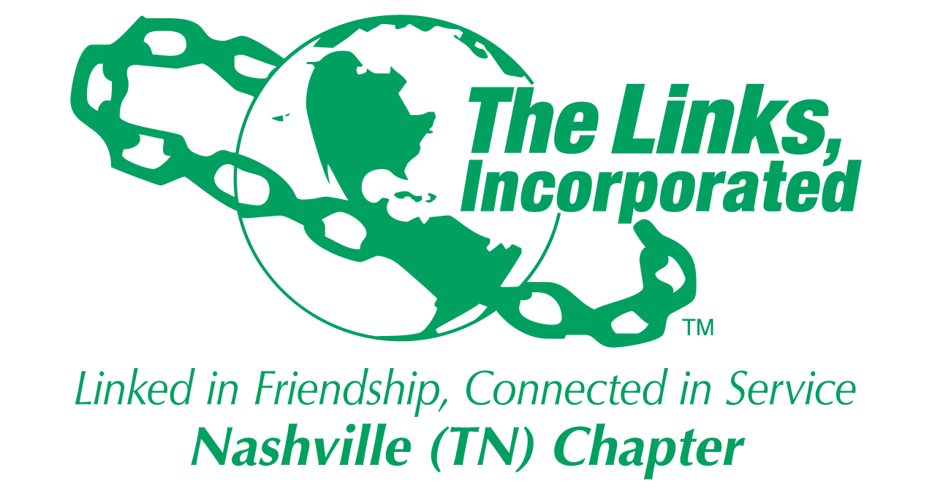
Rescheduled! New Dates! Join Us!
COVID-19 VIRTUAL YOUTH SUMMIT SERIES
For 7th and 8th grade youth

SUMMIT I—The Coronavirus and Our Community

Facts, Myths, Challenges, and Resiliency
Tuesday April 28, 2020 12 Noon - 12:45PM

SUMMIT II—Let’s Get Creative
- Create a digital diary with photography
- Create a face mask with supplies around the house
Wednesday April 29, 2020 12 Noon - 12:45PM

SUMMIT III—Educational Resources to Keep You On Track During The Pandemic
- Resources for successful independent study
- Academic benchmarks to help you prepare for the next grade
- Strategies for Success- resources and habits that can make a difference.
Thursday April 30, 2020 12 Noon – 12:45PM

Sponsored by
The Nashville (TN) Chapter of The Links, Incorporated
This workshop series is designed to offer youth in 7th and 8th grades information about transmission of the coronavirus and provide strategies to promote resilience during the pandemic. Workshop facilitators will share knowledge about the virus and how it affects the African American community, facilitate creative expression through art, and provide academic resources to support independent study while students remain safer at home.
If you have questions please email: garrisea@gmail.com
To register please click the link below: https://www.surveymonkey.com/r/Nashville_Links_Youth_Workshop_Series

